|  |  |  |  |  |  |  |  |  |  |  |  |  |  |  |  |  |
| --- | --- | --- | --- | --- | --- | --- | --- | --- | --- | --- | --- | --- | --- | --- | --- | --- |
|  | **Inputs** | | | | | | | | **Outputs** | | | | | | | |
| Estado | S1 | S0 | Start | Jump | Over | BackMain  menu | Ton | Credits | N1 | N0 | GameOver | Restart | Menu | TurnOn | JumpG | CreditsG |
| Init | 0 | 0 | 0 | x | x | x | x | x | 0 | 0 | 0 | 1 | 1 | 0 | 0 | 0 |
| 1 | x | x | x | x | x | 0 | 1 | 0 | 0 | 0 | 0 | 0 | 0 |
| x | x | x | x | x | 1 | 1 | 1 | 0 | 0 | 1 | 0 | 0 | 1 |
| Run | 0 | 1 | x | 1 | 0 | x | 0 | x | 0 | 1 | 0 | 0 | 0 | 0 | 1 | 0 |
| x | 0 | 0 | x | 1 | x | 0 | 1 | 0 | 0 | 0 | 1 | 0 | 0 |
| x | 1 | 1 | x | 1 | x | 1 | 0 | 1 | 0 | 0 | 1 | 1 | 0 |
| x | 0 | 1 | x | 1 | x | 1 | 0 | 1 | 0 | 0 | 1 | 0 | 0 |
| Game  Over | 1 | 0 | x | x | x | 0 | x | x | 1 | 0 | 0 | 0 | 0 | 0 | 0 | 0 |
| x | x | x | 1 | x | x | 0 | 0 | 0 | 0 | 1 | 0 | 0 | 0 |
| Credits | 1 | 1 | x | x | x | x | x | 0 | 0 | 0 | 0 | 0 | 0 | 0 | 0 | 0 |
| x | x | x | x | x | 1 | 1 | 1 | 0 | 0 | 0 | 0 | 0 | 1 |

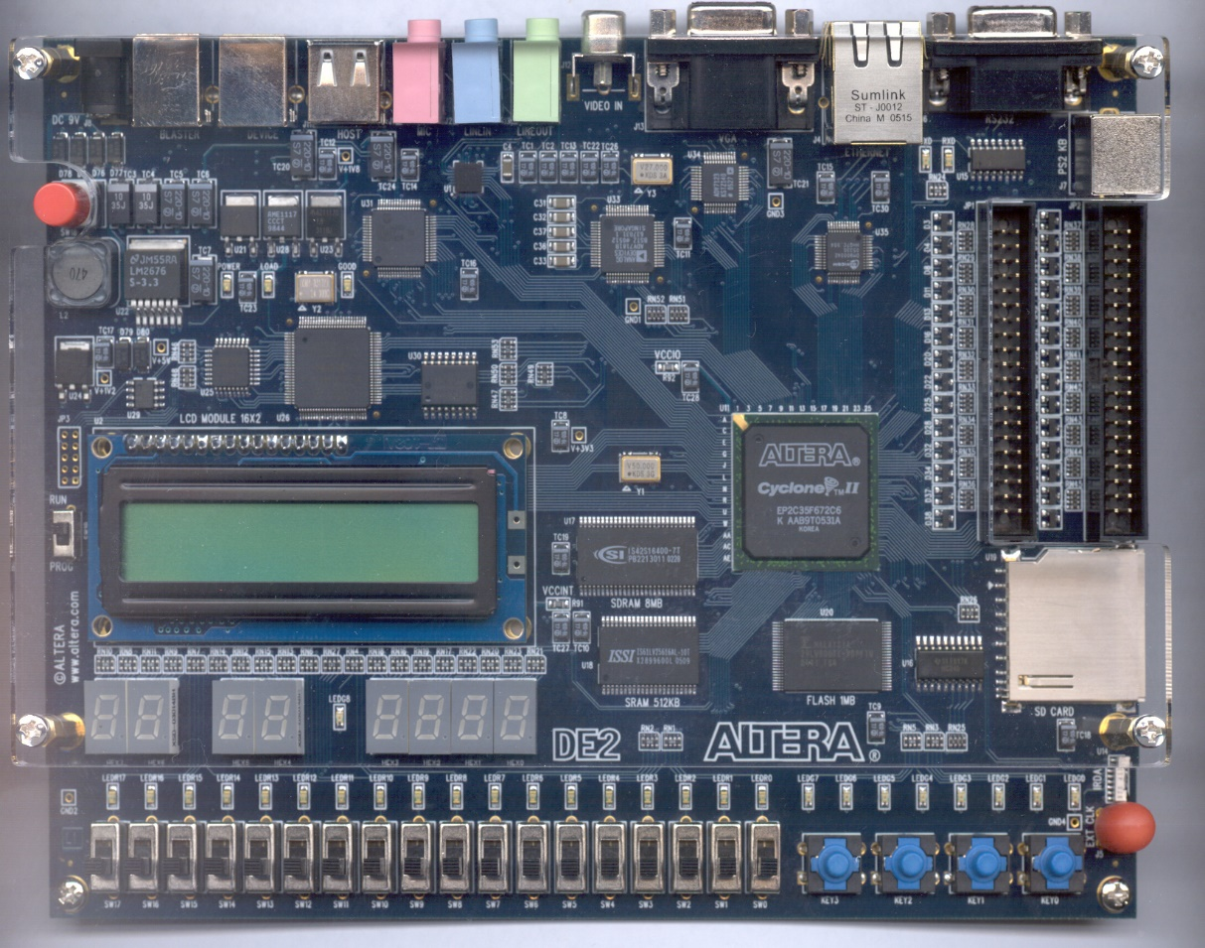

**Mostra os “créditos” do jogo. Nomeadamente autores do projeto e docentes da cadeira.**

**LEDG[7..0] Ficam intermitentes quando as colisões estão ligadas.**

**Mostra o score.**

**LEDR[7..0] Ativam quando o utilizador colide com um obstáculo**

**Indica o número do estado que se encontra.**

**Inputs:**

**Outputs:**

GameOver(bit);

Restart(bit);

Menu(bit);

TurnOn(bit);

JumpG(bit);

CreditsG(bit);

Start(bit);

Jump(bit);

Over(bit);

BackMainMenu(bit);

Ton(bit);

Credits(bit);

**Local Registers:**

Score(5 bits);

Over(bit);

Colisions_On(bit);

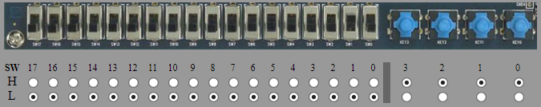

Credits

Jump

Start

Activate Collisions

BackMainMenu